

Head injury In Adult Patients:
Assessment and Early Management

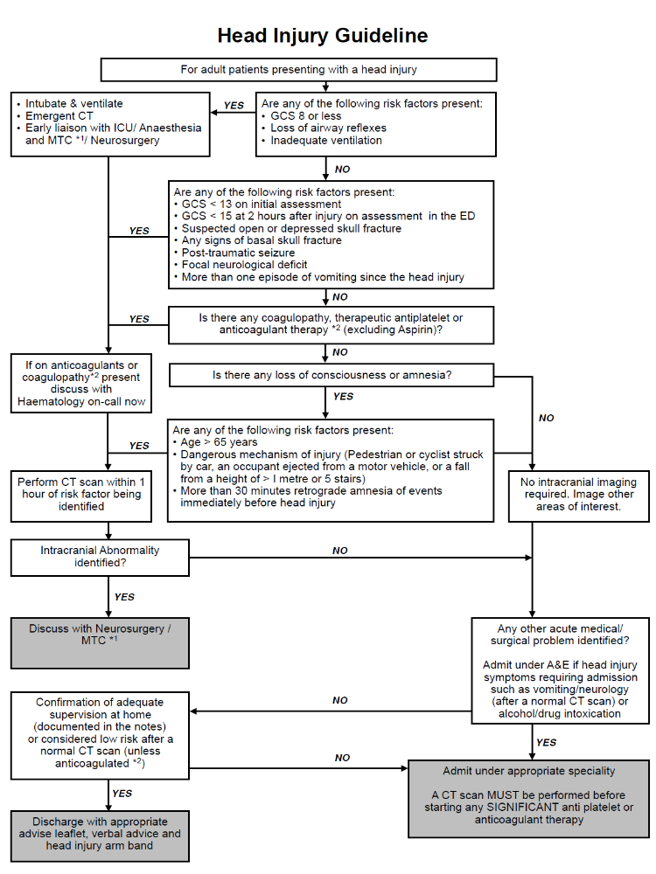

Reference Number: CPME133 |  | Version Number: | 1

Head injury: Assessment and Early Management

What is this document for? | This guidance describes the care provided for any adult patient, over the age of 16, entering the Pennine Acute Hospitals NHS Trust with a head injury, from assessment, through admission, referral for tertiary care, repatriation, rehabilitation and discharge.  For the purposes of the document a head injury will be defined as any trauma to the head, excluding minor facial injuries. The guidance will clarify the Trust’s position in relation to key operational evidence, and establish proposed actions over the short and longer term.
Who needs to know? | The guidance applies to any clinical area that has contact with a patient with a head injury. This will include:-  - Accident & Emergency and Urgent Care departments,  - Radiology,  - Clinical Decision Unit/Observation Ward,  - Intensive Care Units,  - Orthopaedic, and Acute/General Medical wards,  - Rehabilitation Services
Related PAHNT Documents: | Policy For Major Trauma Team (EDC052)  Guidelines for Whole Body Computed Tomography in Major Trauma (CPDi178)  Cervical Spine Imaging following Trauma in Adults (CPDI122)  Adult Transfer Policy (EDG019)  Standard for Patient Observation Practice (CPDI044)  Enhanced Patient Observation Policy (EDG017 V2)  Discharge Policy (NCME002)
Related Legislation/ Obligations: | Head Injuries: Assessment & Early Management  National Institute for Clinical Excellence  NICE Guidelines CG176 Published date: January 2014  Royal College of Radiology Guidelines in relation to imaging of Head Injury

Accountable Executive: | Prof Matthew Makin, Executive Medical Director, Pennine Acute NHS Trust
Document Author(s): | Dr Jim McCahill  Locum Consultant in Emergency Medicine
Developed with: | Consultants in Emergency Medicine  Consultants in Radiology  CT Reporting Radiographers  Consultants in Anaesthetics and Intensive Care  Safeguarding
Ratified by: | 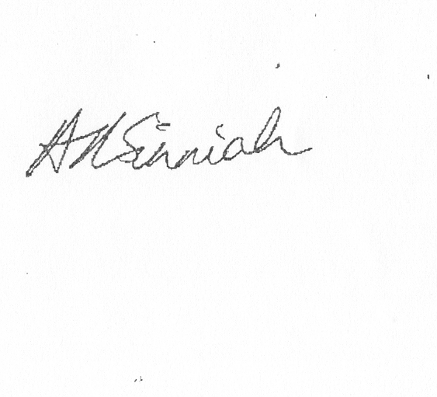Dr Anton Sinniah, Safety Committee Chair & Deputy Medical Director
Date Ratified: | 27th July 2016
Replaces: | There appears to be no previous document except Internal Emergency Department Aide Memoir
How is this different from the previous document? | Full review of NICE Guidelines and incorporating new guidance.
What dissemination & training arrangements have been made? | This Policy will be available via the Document Management System. It will form part of the Trust’s Foundation Education Programme and remain established in each Emergency Departments Induction Programmes.
Review arrangements: | Review every 3 years or earlier should a change in legislation best practice or other circumstance dictate
Safety Arrangements: | Compliance & effectiveness of this policy will be via accident, incident & complaints monitoring, in addition to compliance audits.

Priority Level: | 1
Impact Level: | Trustwide
Keywords: | Head Injury. CT Brain. Trauma.
Contents Page

1. What is this policy for? 5
2. Why do I need to know? 5
3. What is the guidance - Assessment & Management in the Emergency Department

3.1 Adult Head Injury Algorithm 5

3.2 Major Trauma Centre Referral 5

3.3 Safeguarding 5

3.4 Investigating injuries to the cervical spine 5

3.5 Head Injury Documentation 6

3.6 Patients requiring Neurosurgical referral 6

3.7 Patients with Coagulopathies or significant antiplatelet therapy 7

3.8 Transfer from hospital to a Neurosurgical unit or Major Trauma Unit 7

3.9 Admission for observation 7

3.10 Observation of admitted patients 8

3.11 Emergency Department Head Injury Discharge and follow-up 9

3.12 Non-Emergency Department Discharges & follow-up 10

3.14 Patients re-presenting to the Emergency Department following Head Injury 10

4. List of Abbreviations & Terms used 10

5. References 10

6. Appendices
Appendix 1 Equality Impact Assessment 12
Appendix 2 Initial Trauma Assessment 13
Appendix 3 Adult Head Injury Algorithm 14
Appendix 4 Adult Head Injury Ward Proforma 16
Appendix 5 Neurological Observation Chart 18

1. What is this Policy for?

This document sets out local policy for management of adult patients over the age of 16 with a head injury in the Pennine Acute Hospitals NHS Trust. Any deviations from NICE recommendations are documented, and the guidance will be agreed at Trust Board level

2. Why do I need to know?

2.1 Appropriate guidance can enable early detection and treatment of life-threatening brain injury, where present, but also early discharge of patients with negligible risk of brain injury. It can therefore save lives while at the same time preventing needless crowding in emergency departments and observation wards.

3. What is the policy

3.1 Assessment & Management in the Emergency Department – Adult Head Injury Algorithm

See quick summary sheet or appendix 3

3.2 Major Trauma Centre Referral

See Policy for the Major Trauma Team (EDC052)

3.3 Safeguarding

See Policy for Safeguarding Strategy (EDN010)

A clinician with training in safeguarding should be involved in the initial assessment of any patient with a head injury presenting to the emergency department. If there are any concerns identified, document these and follow safeguarding procedures appropriate to the patient's age.

For further safeguarding information see Policy for Safeguarding Strategy (EDN010)

3.4 Investigating injuries to the cervical spine

Associated Cervical spine injury must be considered in all patients presenting with head injuries.

Imaging considerations are documented within the Policy for Cervical Spine Imaging following Trauma in Adults (CPDI122).

3.5 Head Injury Documentation

Throughout the hospital episode, include the head injury proforma in documentation when assessing and observing patients with head injury.
See appendix 4

3.6 Patients requiring Neurosurgical referral

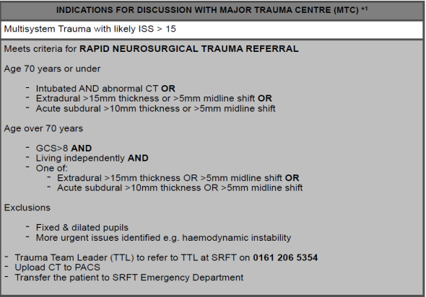
Patients presenting with the following inclusion criteria with no exclusion criteria should be transferred directly to Salford Royal Foundation Trust (Rapid Neurosurgical Trauma Referral).

3.6.1 Discuss with a neurosurgeon the care of all patients with new abnormalities on imaging.

3.6.2 Regardless of imaging, other reasons for discussing a patient's care plan with a neurosurgeon include:
- Persisting coma (GCS 8 or less) after initial resuscitation.
- Unexplained confusion which persists for more than 4 hours.
- Deterioration in GCS score after admission (greater attention should be paid to motor response deterioration).
- Progressive focal neurological signs.
- A seizure without full recovery.
- Definite or suspected penetrating injury.
- A cerebrospinal fluid leak.

3.7 Patients with Coagulopathies or significant antiplatelet therapy
Discuss any coagulopathies with Haematologist on call. Consider any recent Thrombolysis, Catheter lab intervention or any haemodialysis.
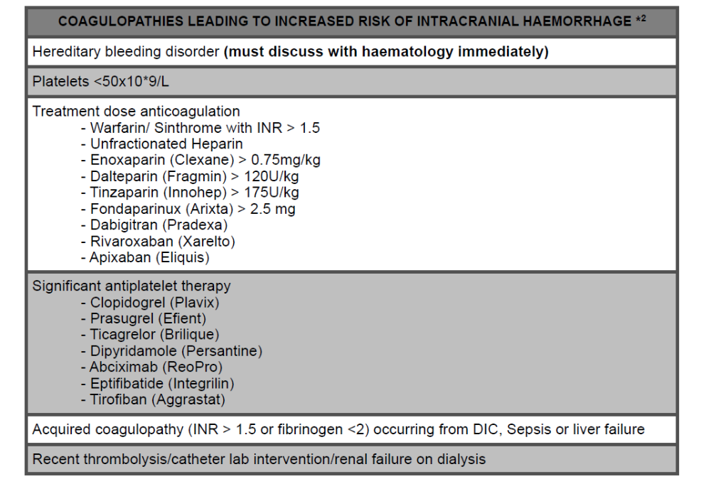

3.8 Transfer from hospital to a Neurosurgical unit or Major Trauma Unit
All transfers are subject to the Adult Transfer policy (EDG019) and must be accompanied by the Trust’s Transfer documentation.

3.9 Admission for observation
3.9.1 Use the criteria below for admitting patients to hospital following a head injury:
- Patients with new, clinically significant abnormalities on imaging.
- Patients whose GCS has not returned to 15 after imaging, regardless of the imaging results.
- When a patient has indications for CT scanning but this cannot be done within the appropriate period, either because CT is not available or because the patient is not sufficiently cooperative to allow scanning.
- Continuing worrying signs (for example, persistent vomiting, severe headaches) of concern to the clinician.
- Other sources of concern to the clinician (for example, drug or alcohol intoxication, other injuries, shock, suspected non-accidental injury, meningism, cerebrospinal fluid leak).

3.9.2. Admit patients with multiple injuries under the care of the team that is trained to deal with their most severe and urgent problem.

3.9.3 In circumstances where a patient with a head injury requires hospital admission, admit the patient only under the care of a team led by a consultant, usually the ED consultant who has been trained in the management of this condition during their higher specialist training. The Consultant and their team should have competence in assessment, observation and indications for imaging, inpatient management; indications for transfer to a neurosurgical unit and hospital discharge and follow-up

3.10 Observation of admitted patients
3.10.1 In-hospital observation of patients with a head injury should only be conducted by professionals competent in the assessment of head injury.

3.10.2 For patients admitted for head injury observation, neurological observations should be documented on the Neurological observation Chart and include as a minimum :
- GCS;
- pupil size and reactivity;
- limb movements;
- respiratory rate;
- heart rate;
- blood pressure;
- temperature;
- blood oxygen saturation.

3.10.3 Perform and record observations on a half-hourly basis until GCS equal to 15
has been achieved. The minimum frequency of observations for patients with
GCS equal to 15 should be as follows, starting after the initial assessment in the Emergency Department:
- Half-hourly for 2 hours.
- Then 1-hourly for 4 hours.
- Then 2-hourly thereafter.

3.10.4 Should the patient with GCS equal to 15 deteriorate at any time after the initial 2-hour period, observations should revert to half-hourly and follow the original frequency schedule.

3.10.5 Any of the following examples of neurological deterioration should prompt
urgent reappraisal by the supervising doctor.
- Development of agitation or abnormal behaviour.
- A sustained (that is, for at least 30 minutes) drop of 1 point in GCS score (greater weight should be given to a drop of 1 point in the motor response score of the GCS).
- Any drop of 3 or more points in the eye-opening or verbal response scores of the GCS, or 2 or more points in the motor response score.
- Development of severe or increasing headache or persisting vomiting.
- New or evolving neurological symptoms or signs such as pupil inequality or asymmetry of limb or facial movement

3.10.7 If any of the changes are confirmed, an immediate CT scan should be considered, and the patient's clinical condition re-assessed and managed appropriately.

3.10.8 In the case of a patient who has had a normal CT scan but who has not achieved GCS equal to 15 after 24 hours' observation, a further CT scan or MRI scanning should be considered and discussed with the radiology department.

3.11 Emergency Department Head Injury Discharge and follow-up

3.11.1 Do not discharge patients presenting with head injury until they have achieved GCS equal to 15.

3.11.2 Do not discharge patients if other factors that would warrant a
hospital admission are present (for example, drug or alcohol intoxication, other injuries, shock, suspected non-accidental injury, meningism, cerebrospinal fluid leak)

3.11.3 All patients with any degree of head injury should only be transferred to their
home if it is certain that there is somebody suitable at home to supervise the
patient. Discharge patients with no carer at home only if suitable supervision
arrangements have been organised, or when the risk of late complications is
deemed negligible.

3.11.4 Ensure all Emergency Department patients have received a red ‘Head Injury’ wristband.

3.11.5 Ensure patient does not act as main carer to any other dependent person.

3.11.6 Give verbal and printed discharge advice to patients with any degree of head injury who are discharged from an Emergency Department or observation ward, and their families and carers.

3.11.7 Printed advice for patients, family members and carers should be age- appropriate and include:
- Details of the nature and severity of the injury.
- Risk factors that mean patients need to return to the emergency department
- A specification that a responsible adult should stay with the patient for the first 24 hours after their injury
- The patient should not act as main carer to any dependent person for the first 24 hours after their injury
- Details about the recovery process, including the fact that some patients may appear to make a quick recovery but later experience difficulties or complications.
- Contact details of community and hospital services in case of delayed complications.
- Information about return to everyday activities, including school, work, sports and driving.

3.12 Non-Emergency Department Discharges & follow-up

See Discharge Policy (NCME002)

3.13 Patients re-presenting to the Emergency Department following Head Injury

Patients who return to an emergency department within 48 hours of transfer to the community with any persistent complaint relating to the initial head injury should be seen by or discussed with a senior clinician experienced in head injuries, and considered for a CT scan.

4. Abbreviations & Definitions of terms used
CSF Cerebral Spinal Fluid
CT Computed Tomography
DIC Disseminated Intravascular coagulopathy
ED Emergency Department
GCS Glasgow Coma Scale
INR International Normalised Ratio
ISS Injury Severity Score
NICE National Institute for Health and Care Excellence
PACS Picture Archive and Communication System
SRFT Salford Royal Foundation Trust
TTL Trauma Team Leader

5. References and Bibliography

National Institute for Health & Care Excellence (NICE)
Head injury: assessment and early Management
22nd January 2014
https://www.nice.org.uk/Guidance/CG176

Scottish Intercollegiate Guidelines Network (SIGN)
Early Management of patients with a head injury
May 2009
http://www.sign.ac.uk/pdf/sign110

National Clinical Guideline developed by the National Collaborating Centre for Acute Care at The Royal College of Surgeons of England
2007
http://webtest.rcseng.ac.uk/publications/docs/head-injury-triage-assessment-investigation-and-early-management-of-head-injury-in-infants-children-and-adults-update

Royal College of Radiology Guidelines in relation to Imaging in Head Injury
http://nww.irefer.nhs.uk/adult/#Tpc205

Protocol for Cervical Spine Imaging Following Trauma in Adults (CPDI122)
http://nmashanti:86/DMS/DesktopModules/WroxDocs/ViewDocument.aspx?ItemID=1876&mid=9000&key=1876

Trust Adult Transfer Policy –
http://nmashanti:86/DMS/DesktopModules/WroxDocs/ViewDocument.aspx?ItemID=2132&mid=9000&key=2132

Policy For Major Trauma Team (EDC052)

Guidelines for Whole Body Computed Tomography in Major Trauma (CPDI178)
http://nmashanti:86/DMS/DesktopModules/WroxDocs/ViewDocument.aspx?ItemID=2745&mid=9000&key=2745

Standard for Patient Observation Practice (CPDI044)
http://nmashanti:86/DMS/DesktopModules/WroxDocs/ViewDocument.aspx?ItemID=620&mid=9000&key=620

Enhanced Patient Observation Policy (EDG017 V2)
http://nmashanti:86/DMS/DesktopModules/WroxDocs/ViewDocument.aspx?ItemID=1923&mid=9000&key=1923

Discharge Policy (NCME002
http://nmashanti:86/DMS/DesktopModules/WroxDocs/ViewDocument.aspx?ItemID=157&mid=9000&key=157

.

6. Appendices

Appendix 1 Equality Impact Assessment 18
Appendix 2 Initial Trauma Assessment 19
Appendix 3 Adult Head Injury Algorithm 20
Appendix 4 Adult Head Injury Ward Proforma 22
Appendix 5 Neurological Observation Chart 26
This form should be completed in liaison with your Equality Champion as per the ‘Equality Impact Assessment Guidelines’ (EDH062).
Appendix 1 – Equality Impact Assessment

Equality Impact Assessment for: Head injury assessment and early management . CPME133

To be completed by the Lead Author (or a delegated staff member)
For each of the Protected Characteristics & equality & diversity streams listed answer the questions below using  Y to indicate yes and  N to indicate no: | Age | Disability | Ethnicity / Race | Gender | Gender Reassignment | Marriage & Civil Partnership | Pregnancy & Maternity | Religion/belief | Sexual orientation | Human Rights |  | Carers | Please explain your justification
- Does the practice covered have the potential to affect individuals or communities differently or disproportionately, either positively or negatively (including discrimination)? | N | N | N | N | N | N | N | N | N | N |  | N | Policy reflects the risk factor of age and uses it appropriately in risk strategizing.  Discharge documentation is only available in english
- Is there potential for, or evidence that, the proposed practice will promote equality of opportunity for all and promote good relations with different groups? | N | N | N | N | N | N | N | N | N | N |  | N | This policy is applied equally across all groups.
- Is there public concern (including media, academic, voluntary or sector specific interest) in the document about actual, perceived or potential discrimination about a particular community? | N | N | N | N | N | N | N | N | N | N
Your Name: Jim McCahill | Your Designation: Locum Consultant |  |  |  |  |  |  |  |  |  | Signed*: Jim McCahill |  |  | Date: 18/5/2016

To be completed by the relevant Equality Champion following satisfactory completion & discussion of answers above with author
Equality Champion: Louise Williams | Directorate: Medicine | Signed*: 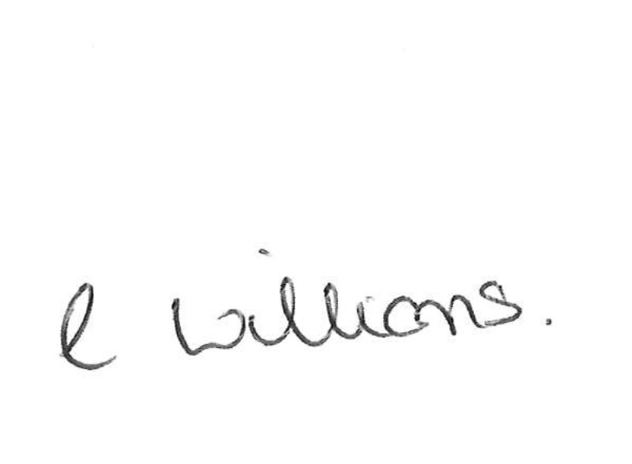 | Date: 1.6.16
*Please scan or insert electronic signature
Appendix 2
Initial Trauma Assessment

- All patients with Head Injuries with any high risk mechanism MUST be assessed by a Clinician of ST3 or above within 5 mins of arrival

- All patients presenting with Head Injury must be considered for an associated Cervical Spine Injury

- All patients presenting with a Head Injury with any high risk mechanism and any anatomical considerations and physiological derangements MUST be discussed with the MTC
- High Risk Mechanism | - Anatomical Considerations | - Physiological
RTC with death of another passenger in the same vehicle  RTC with ejection of casualty  Pedestrian / cyclist / motorcyclist versus vehicle  Fall > 1 metre / 5 steps | Visible Injury to > 2 body regions  Hard signs of vascular injury  - Expanding Haematoma  - Deep Laceration over arterial course  Hard Signs of Spinal Cord Injury | GCS <12  - Or Intubated  - Or Surgical Airway  Systolic BP <90 mmHg in the ED  Respiratory Rate <10 or >30 per min  Pulse > 120 bpm in the ED  Age > 65yrs  Anticoagulants

3. Adult Head Injury Algorithm

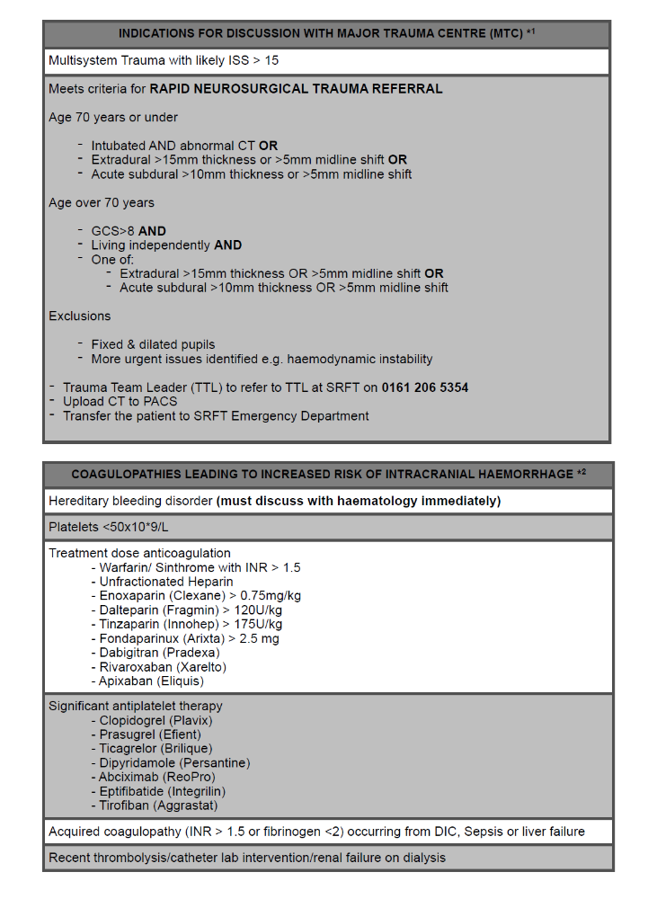
- Adult Head Injury Ward Proforma

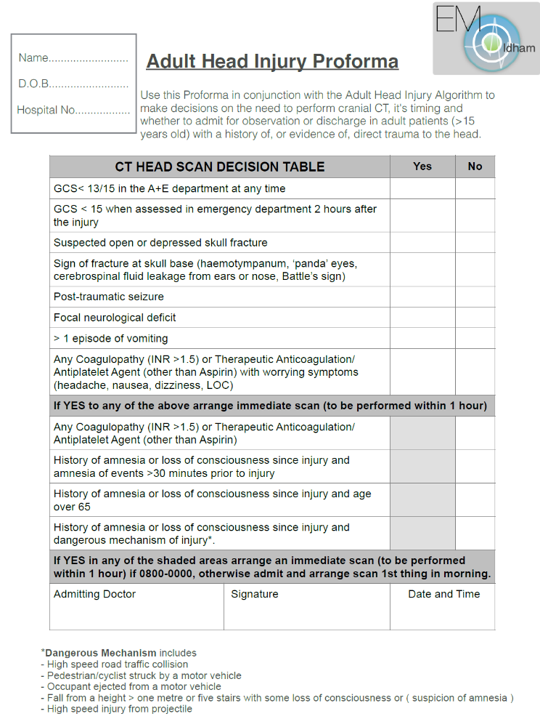
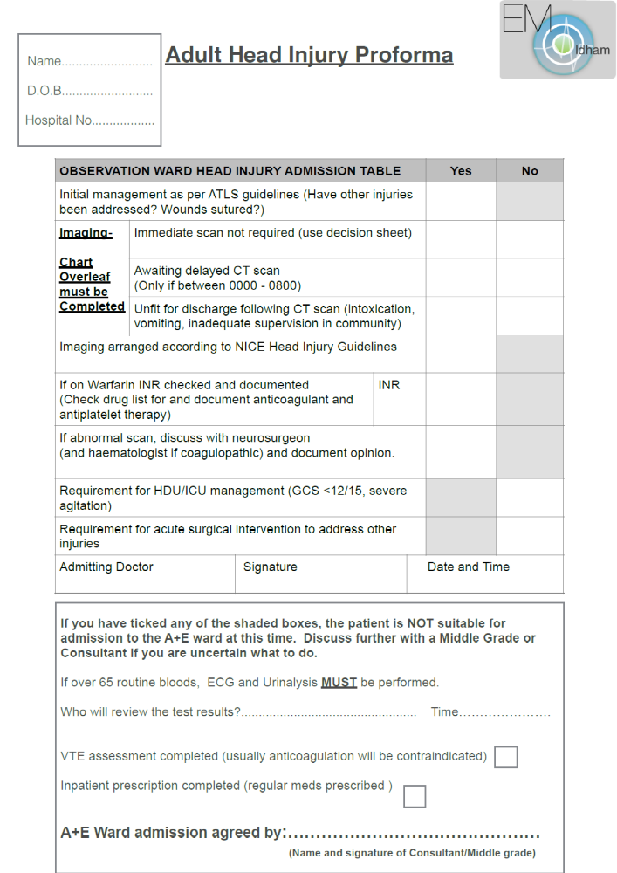

- Neurological Observation Chart


